 ***UNIVERSITY OF PUNJAB***

*GUJRANWALA CAMPUS*

*Sialkot bypass, Near Ali Pur Chowk, Gujranwala, Punjab, Pakistan*

***Certificate***

*Certified that this is Bonafede record of the project work entitled*

***“VEHICLE DETECTION AND COUNTING”***

***PRESENTED BY***

* ***AROOJ FATIMA(BIT-21002)***
* ***FAJAR SARFARAZ (BSIT-21038)***

***“A FUNDAMENTAL STUDY OF*** **COMPUTER VISION”**

Ms Fouqia Dr.Naveed Ahmad Khan

*Project Advisor*  *Head of the Department*

**Date:** *|February 08,2025*

## ***Table of Contents***

1. Introduction
2. Problem Statement
3. Objectives
4. Scope of the Project
5. Methodology
6. Algorithm Used
7. Implementation Details
8. Results and Discussion
9. Conclusion
10. Future Enhancements

***Vehicle Detection and Counting System Documentation***

## **1. Introduction**

Vehicle detection and counting play a crucial role in traffic monitoring, urban planning, and transportation management. This project aims to develop a system that automatically detects and counts vehicles in a video stream using computer vision techniques. By utilizing background subtraction and contour detection, the system accurately identifies vehicles passing through a predefined counting line.

## **2. Problem Statement**

With increasing urban traffic congestion, there is a need for automated systems that can efficiently monitor and count vehicles. Traditional methods rely on manual counting or expensive hardware setups such as inductive loop sensors. This project provides a cost-effective and efficient computer vision-based solution for real-time vehicle counting.

## **3. Objectives**

* To develop a system that can automatically detect and count vehicles in a video stream.
* To utilize background subtraction and contour detection for object tracking.
* To display real-time vehicle count on the screen.
* To ensure accuracy and efficiency in detection.
* To make the system adaptable for different environments and video inputs.

## **4. Scope of the Project**

* This project focuses on detecting and counting vehicles using a pre-recorded video.
* It employs OpenCV for image processing and vehicle detection.
* The system can be extended to real-time surveillance with live camera feeds.
* It does not classify vehicle types but can be improved with deep learning techniques.

## **5. Methodology**

The system follows these steps:

1. Capture frames from the video.
2. Convert frames to grayscale for better processing.
3. Apply Gaussian blur to reduce noise.
4. Use background subtraction to detect moving objects.
5. Apply morphological operations to remove small noise.
6. Find contours of the detected objects.
7. Draw bounding boxes around detected vehicles.
8. Track the center of each vehicle.
9. Count vehicles as they cross a predefined counting line.

## **6. Algorithm Used**

This project uses the **Background Subtraction Algorithm (MOG)** along with **Contour Detection** for vehicle detection. The key steps include:

### **Background Subtraction (MOG - Mixture of Gaussians)**

* We use cv2.bgsegm.createBackgroundSubtractorMOG() to extract moving objects from the video.
* The algorithm models the background over time and subtracts it from each frame, highlighting foreground objects (vehicles).

### **Morphological Operations**

* We apply dilation and closing operations to remove small noise and enhance the detected vehicles.
* cv2.morphologyEx() helps in closing gaps in detected contours.

### **Contour Detection**

* We use cv2.findContours() to detect vehicle boundaries.
* A bounding box is drawn around each detected vehicle using cv2.boundingRect().

### **Vehicle Counting Mechanism**

* A predefined counting line is drawn at a specific position.
* The center of each vehicle is tracked using a custom function.
* If a vehicle’s center crosses the line, it is counted and removed from the tracking list.

## **7. Implementation Details Technologies Used**

* Python
* OpenCV
* NumPy

### **Code Explanation**

### **1. Video Capture:**

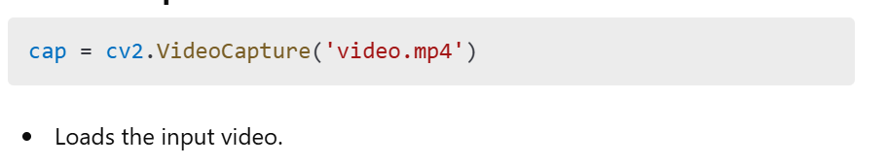

### **2. Preprocessing:**

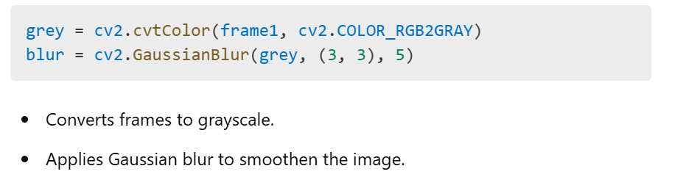

### **3. Background Subtraction:**

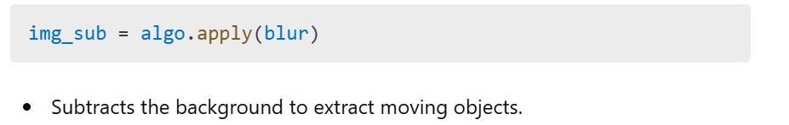

### **4. Morphological Operations:**

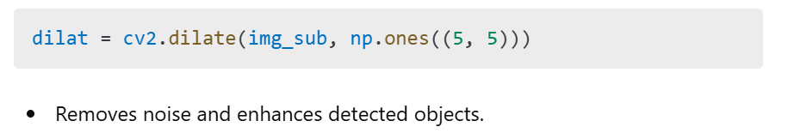

### **5. Contour Detection:**

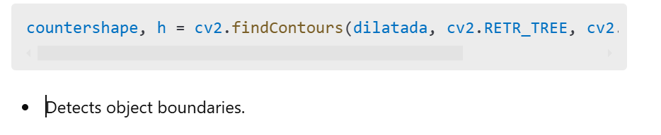

### **6. Vehicle Counting:**

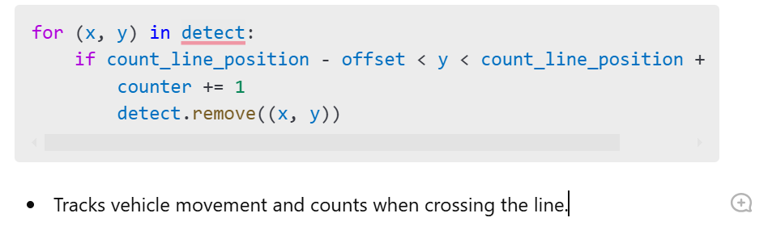

## **Screenshots:**

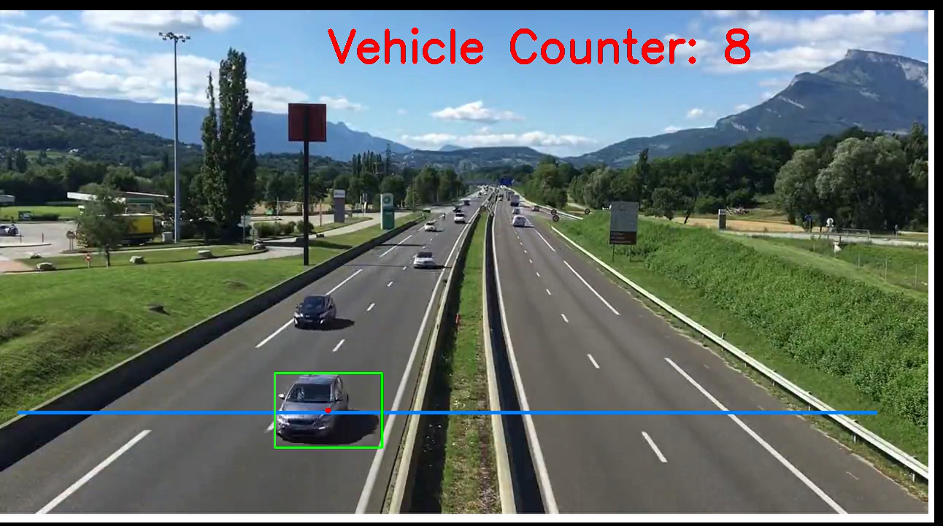

## **C:\Users\HP\Pictures\Screenshots\Screenshot (143).png**

## **8. Results and Discussion**

* The system successfully detects and counts vehicles in the given video.
* It can track multiple vehicles simultaneously.
* The accuracy depends on the quality of the video and lighting conditions.
* Minor errors may occur when vehicles overlap.

## **9. Conclusion**

This project demonstrates an efficient method for vehicle detection and counting using computer vision. By leveraging background subtraction and contour detection, the system accurately tracks vehicles. The approach is suitable for traffic monitoring and can be extended to real-time surveillance systems.

## **10. Future Enhancements**

* **Real-time implementation:** Integrate with live camera feeds.
* **Vehicle classification:** Identify different types of vehicles.
* **Deep learning integration:** Improve accuracy using CNNs.
* **Multiple lane detection:** Enhance counting across multiple lanes.